*Resource Name or Address 619 6th Street
P1. Other Identifier: None
*P2. .Location: *a. County Yolo
b. Address 619 6th Street
*c. City Davis Zip 95616
d. UTM: N/A
e. USGS Quad: Davis Quadrangle
*f. Other Locational Data (APN #): 070 182 014
*P3a. Description:
A rectangular bungalow with a low pitched side gable roof, this house has a rustic quality. Gable ends have wide overhangs and the eaves exhibit exposed rafter ends. Symmetrical ribbons of multi-light wooden casement windows flank the multi-light, centered entry door. The windows extend the full length of the front façade and give the house the appearance of a mountain cabin. A small bracketed shed roof extends over the entry stoop. Cladding is clapboard. The house retains its integrity of design, materials, workmanship, setting, location, feeling and association . It appears to be unaltered and it contributes to a district eligible for the California Register.
*P3b. Resource Attributes: HP2
*P4. Resources Present:  Building □ Structure □ Object □ Site □ District  Element of District
P5b. Description of Photo:
View north
*P6. Date Constructed/Age:
1932 71 years old documented
□ Prehistoric  Historic
□ Both
*P7. Owner and Address:
P5. Photograph or Drawing (Photograph required for buildings, structures,
and objects.)

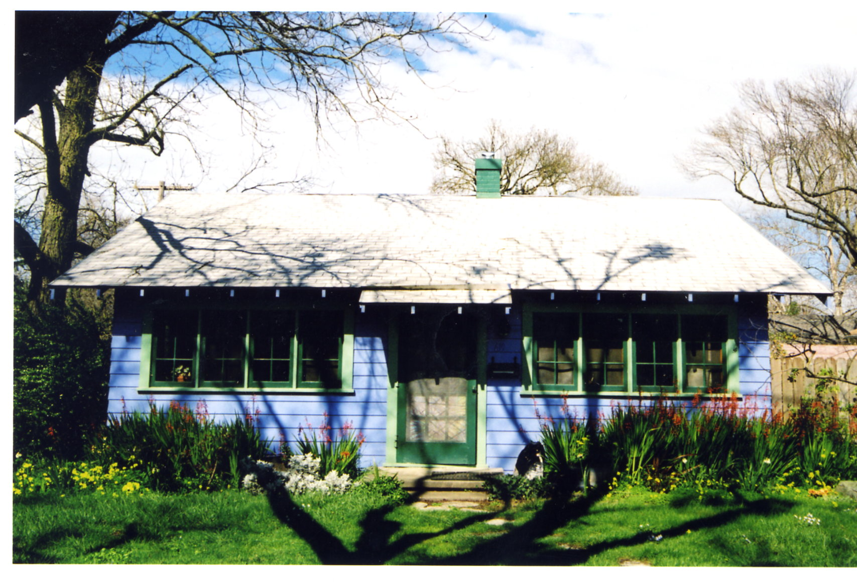
Laura Benninger
619 6th Street
Davis, CA 95616
*P8. Recorded by:
Carol Roland
Roland-Nawi Associates
4829 Crestwood Way
Sacramento, CA 95822
*P9. Date Recorded: 04/07-10/2003
*P10. Type of Survey:  Intensive
□ Reconnaissance □ Other
Describe: Determination of
Local District Eligibility
*P11. Report Citation: none
*Attachments: □ NONE □ Map Sheet □ Continuation Sheet  Building, Structure, and Object Record □ Linear Resource Record □ Archaeological Record □ District Record □ Milling Station Record □ Rock Art Record
□ Artifact Record □ Photograph Record □ Other (List):

