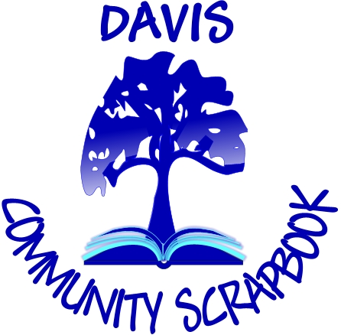
Submission Form

Name___________________________________________________________

Address_________________________________________________________

________________________________________________________________

Telephone number _______________________________________________

Email___________________________________________________________

Title of Story, Song, Photograph, Painting

________________________________________________________________

Would you be willing to perform or read or tell your contribution in a public presentation? Yes__________ No__________

Please keep your submission to 350 words or what can be said, sung, or performed in 3 minutes. Submissions may be written, audio or video or a photograph or painting. Completed stories may be sent by email to the scrapbook curator:
Jean Jackman jljackma@dcn.org (note no "n" in email name) or mail to 306 Del Oro Ave., Davis, CA 95616.

If possible, please include a photo of yourself and if possible, a photo pertinent to your story. If you get stuck in your story, need help with revisions, contact Jean Jackman who will arrange for a volunteer to help you. Write any questions on the back of this form.

I give my permission for my scrapbook submission to be included on the website, on exhibits, used at performances or other activities of Davis Community Scrapbook with no remuneration.

Your signature ____________________________________________________

Date______________________________________________________________
DCS is funded in part by a City of Davis Arts Contract Grant.

